Cloud Computing

Title: Cloud Based Compiler

Mentor: Dr. Sanjay Chaudhary

Members:

1401025 – Shreyas Patel

1401075 – Ashutosh Kakadiya

1401076 – Mihir Gajjar

1401086 – Harsh Mehta

Introduction

Build cloud based web application that provides developer an interface which helps in code compilation, execution, analysis and also provides code optimisation related suggestion if required in code.

Work Done

1. Successfully integrated compilers at server side
2. Created service oriented architecture for Code Editor
3. Implemented authentication service for user SignIn / SignUp
4. Designed a database and integrated it with the system
5. Implemented file storage system – Users can store their code on cloud
6. Users can show their activity on their dashboard
7. Developed an optimization service

Tools / Packages

* Front-end technology
  1. HTML , CSS, Javascript
* Back-end technology
  1. Python, Flask, Jinja
* Database
  1. MySQL

Dataflow Diagram

* This diagram shows how data flows in the system

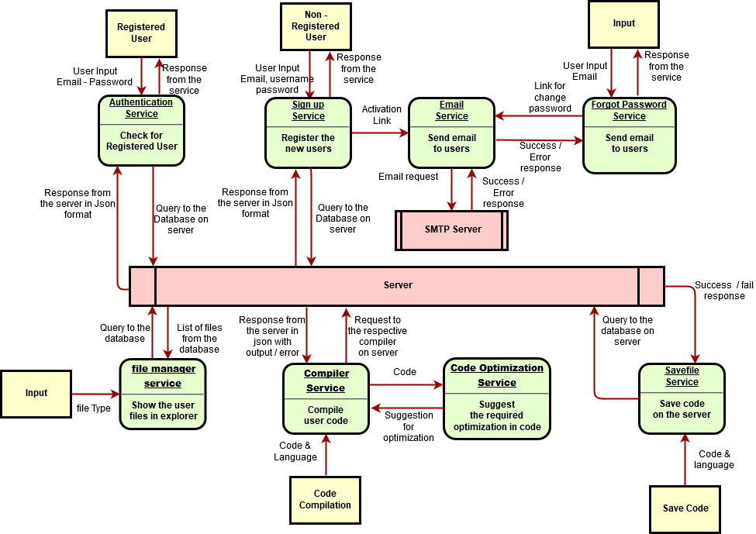

Database Schema

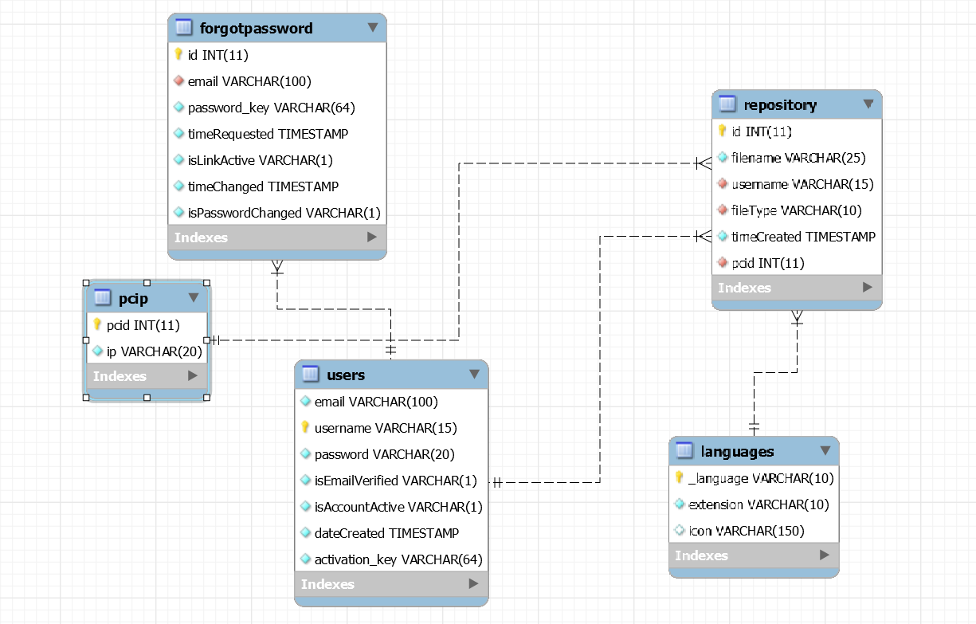

Screenshots

* Home Screen  
    
  
* Login Screen  
    
    
  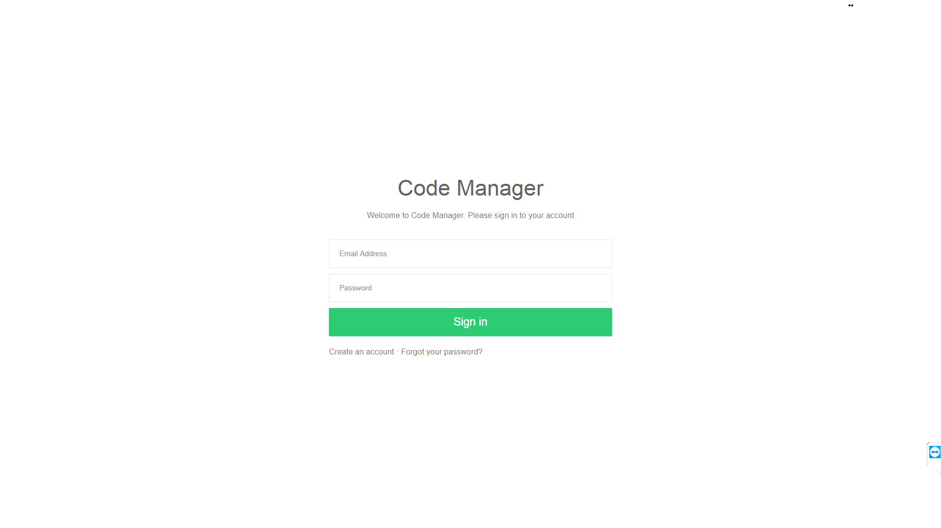

* Error based on user side input validation   
    
  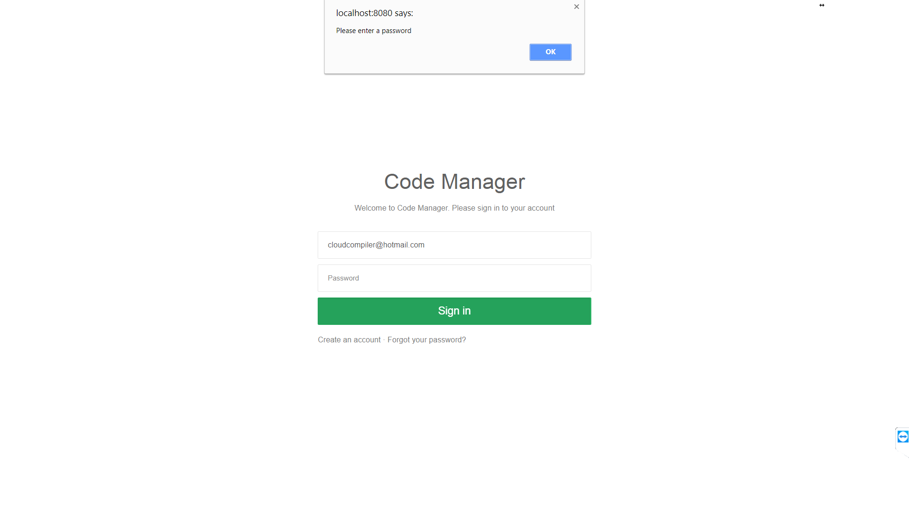
* Error based on server side validation  
    
  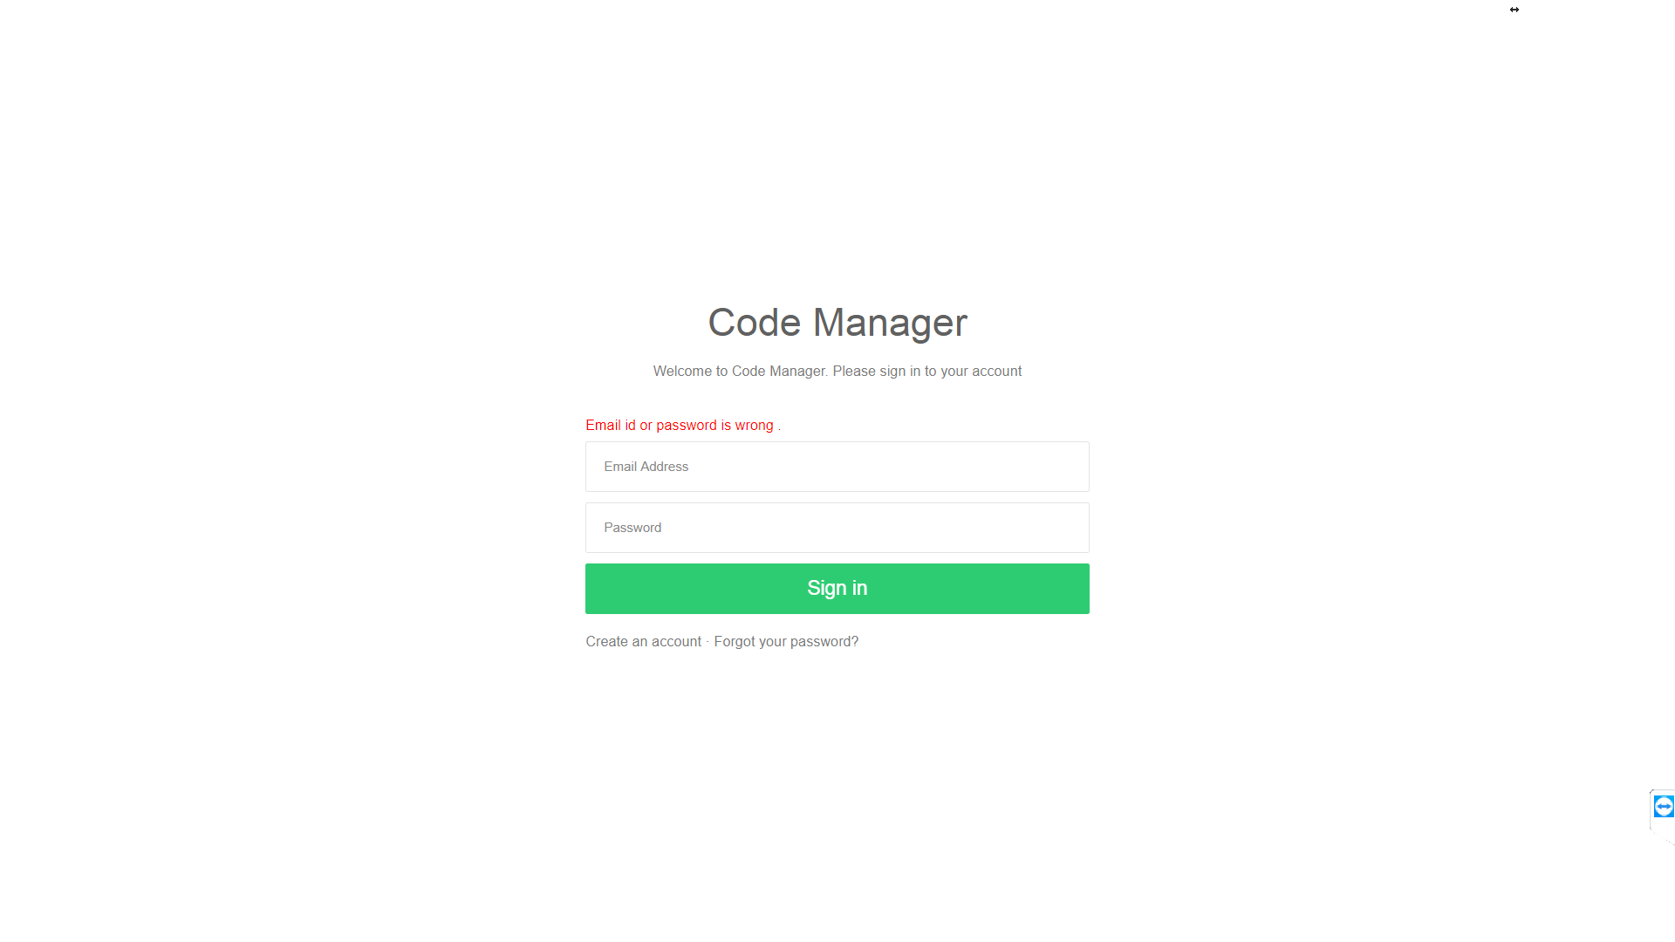
* User need to verify the account before login by clicking the link sent to user’s mail account  
    
  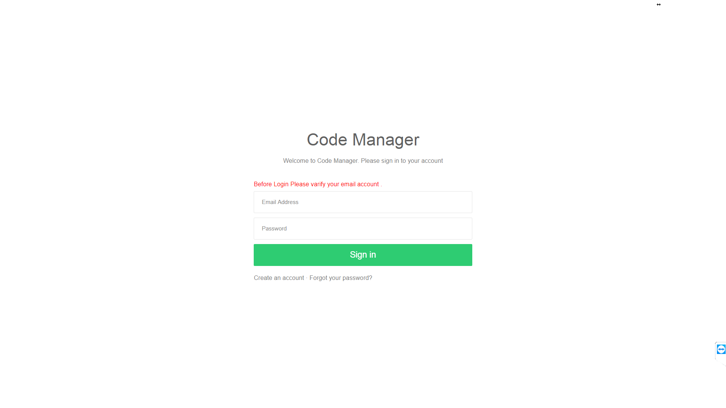
* Sign up screen  
    
  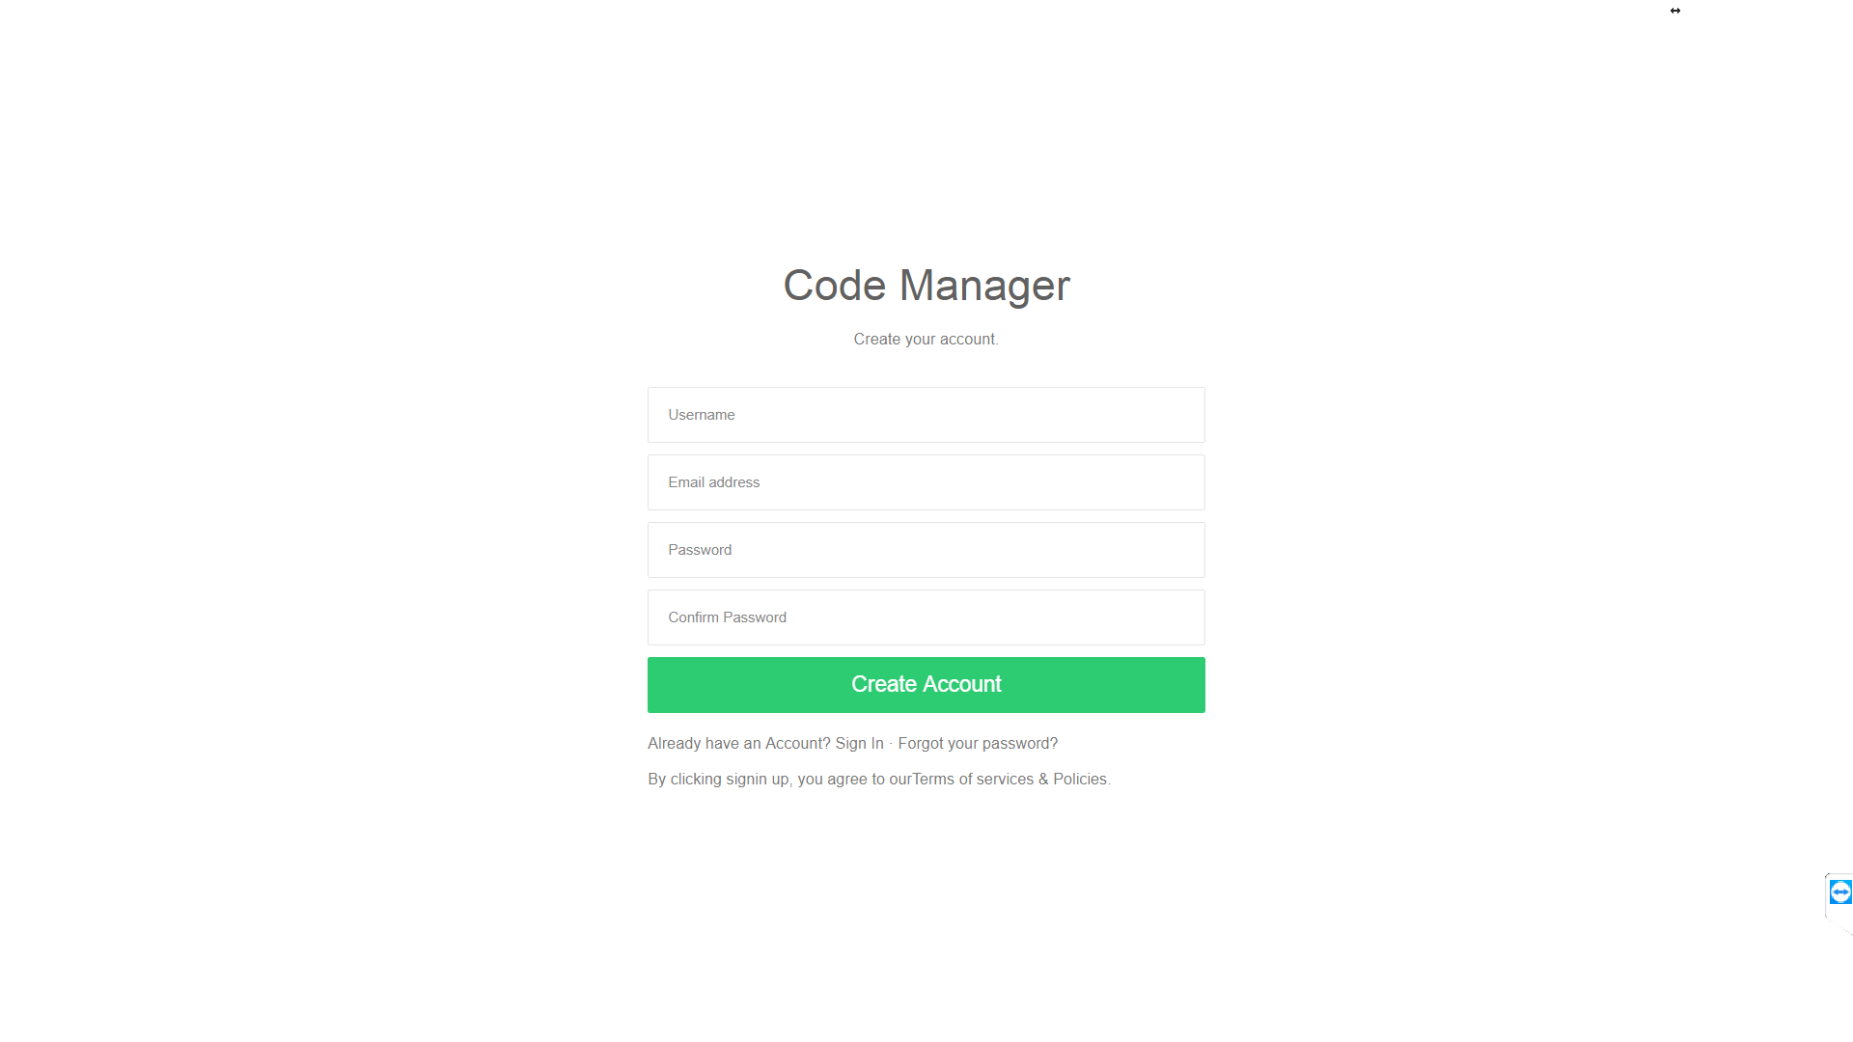
* Server side validation for sign up  
    
  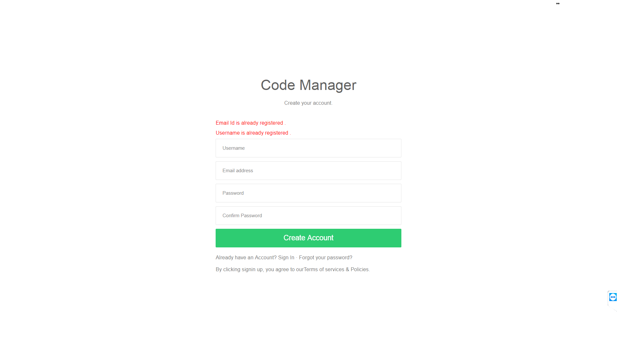
* Forgotpassword Screen  
    
  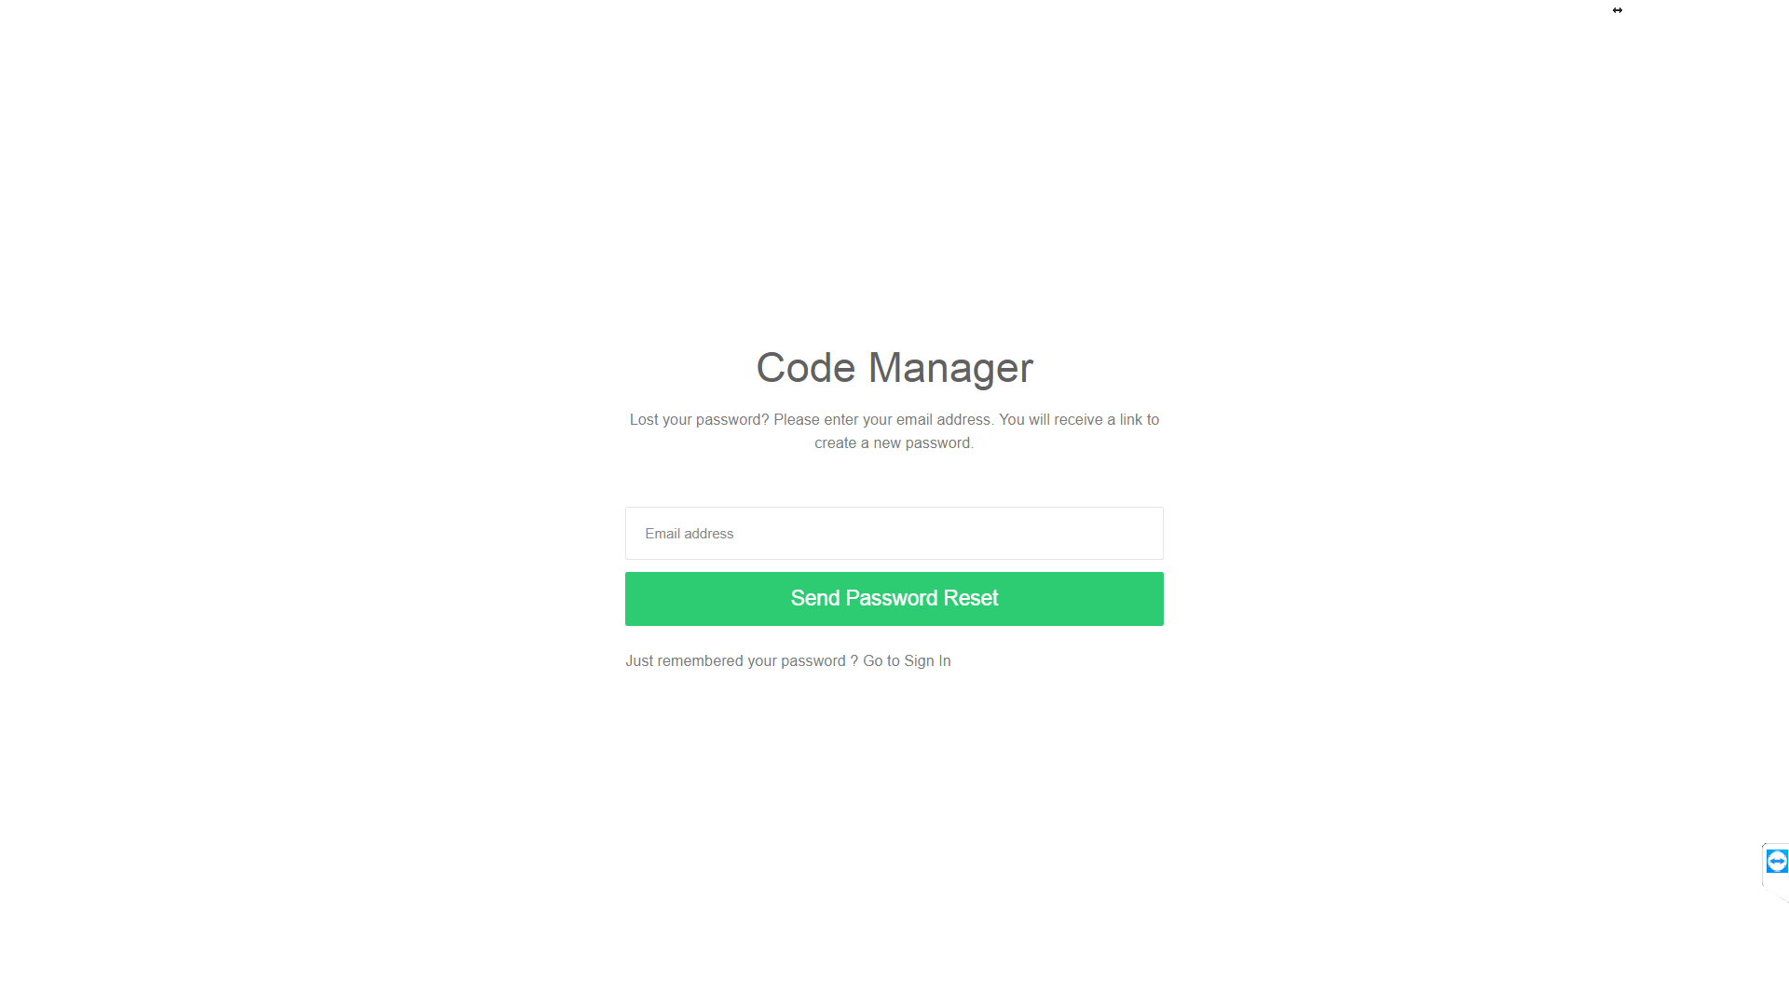
* Userside validation for forgotpassword   
    
  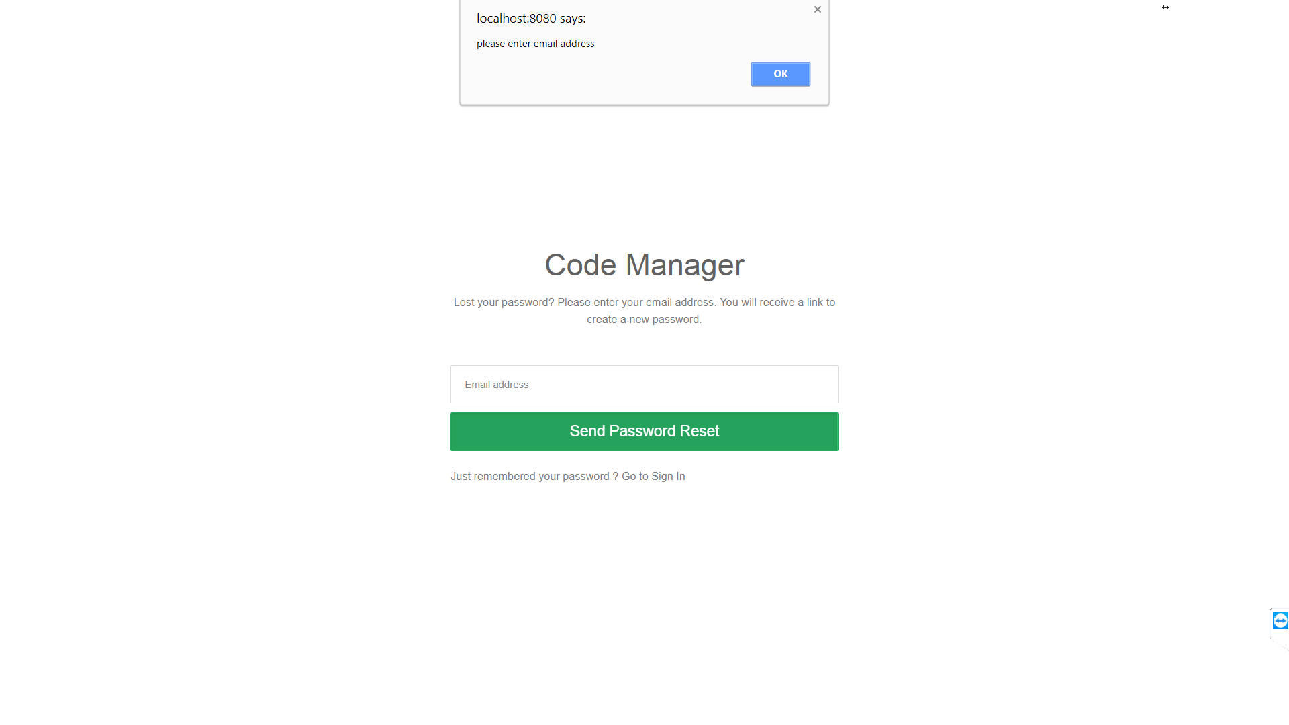
* Link sent to user to activate account  
    
  
* After clicking the sent link  
    
  
* Code Editor screen  
    
  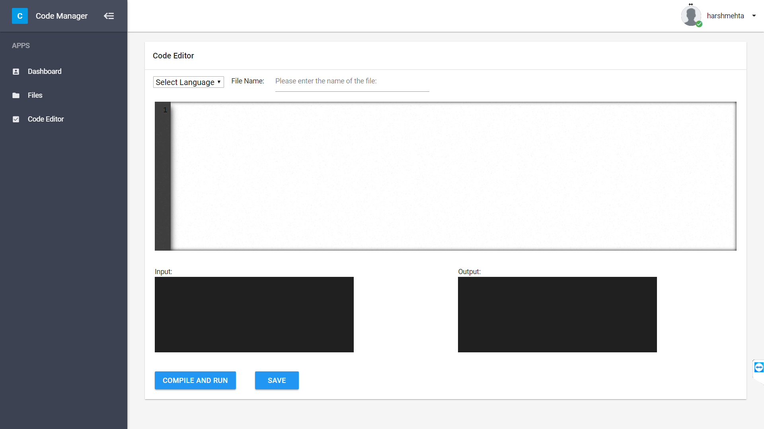
* Compilation error is showing in output  
    
  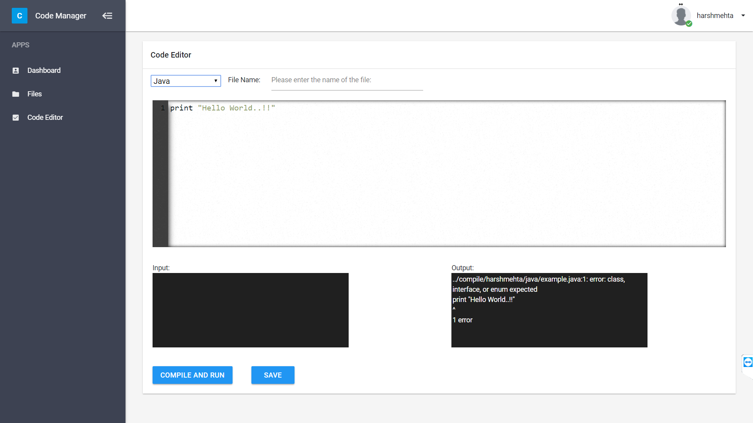
* Successful compilation  
    
  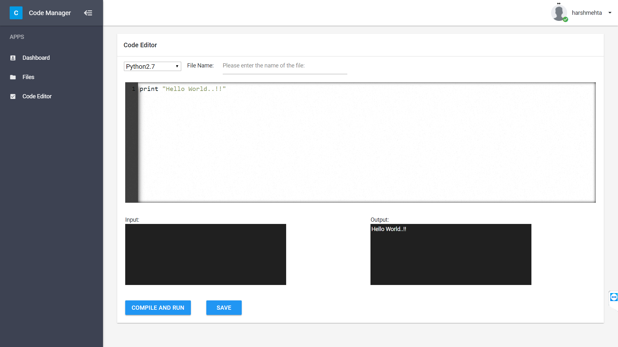
* Save file  
    
  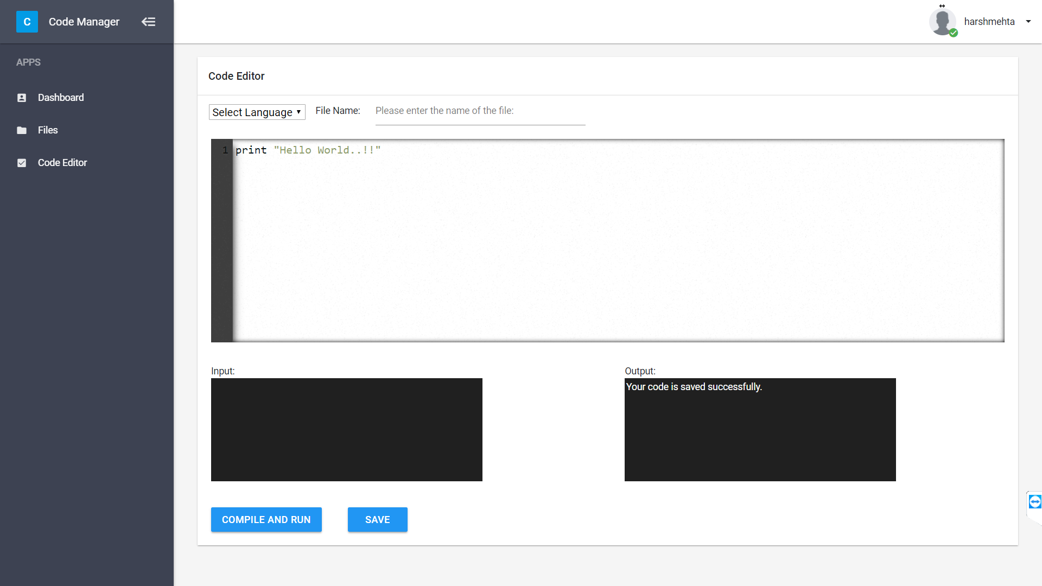
* File manager screen   
    
  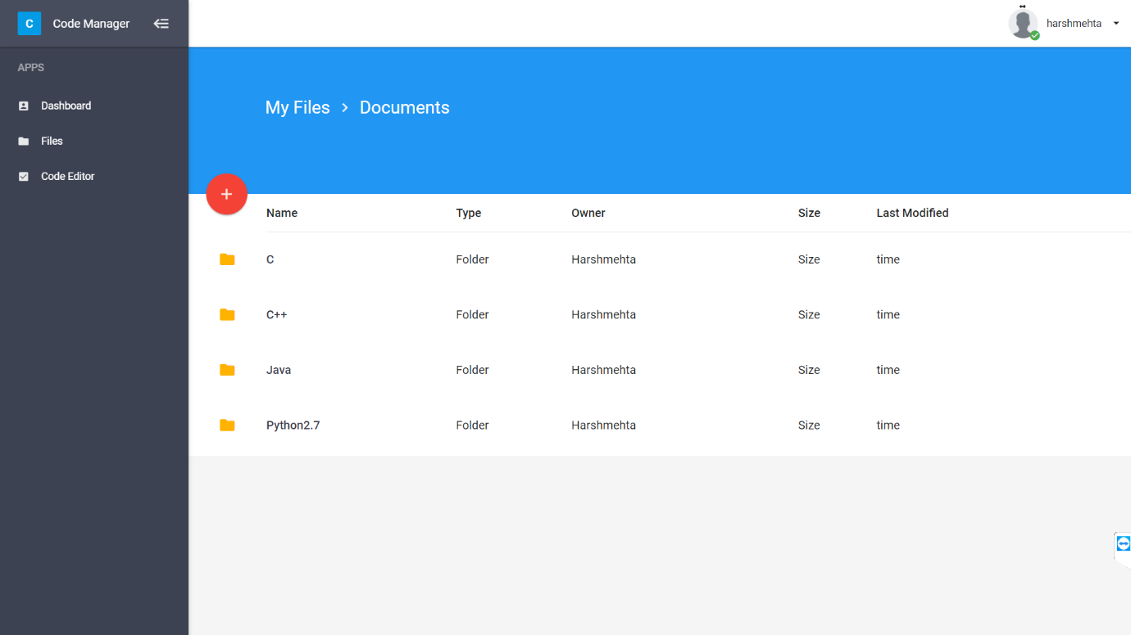  
    
    
    
    
  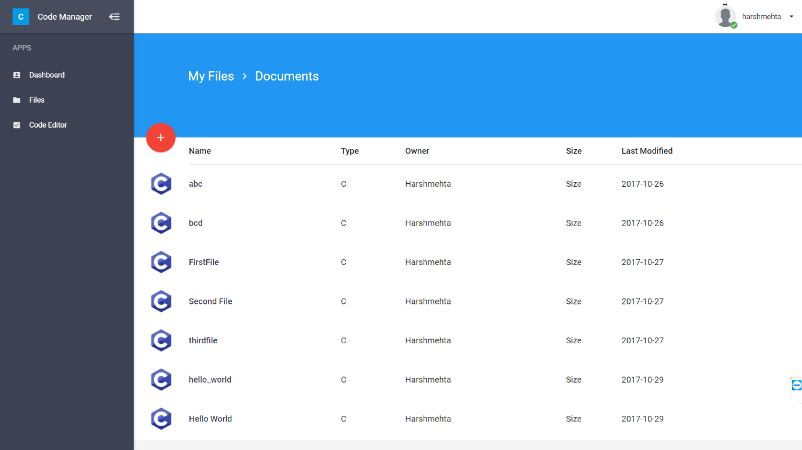  
    
    
    
    
    
    
  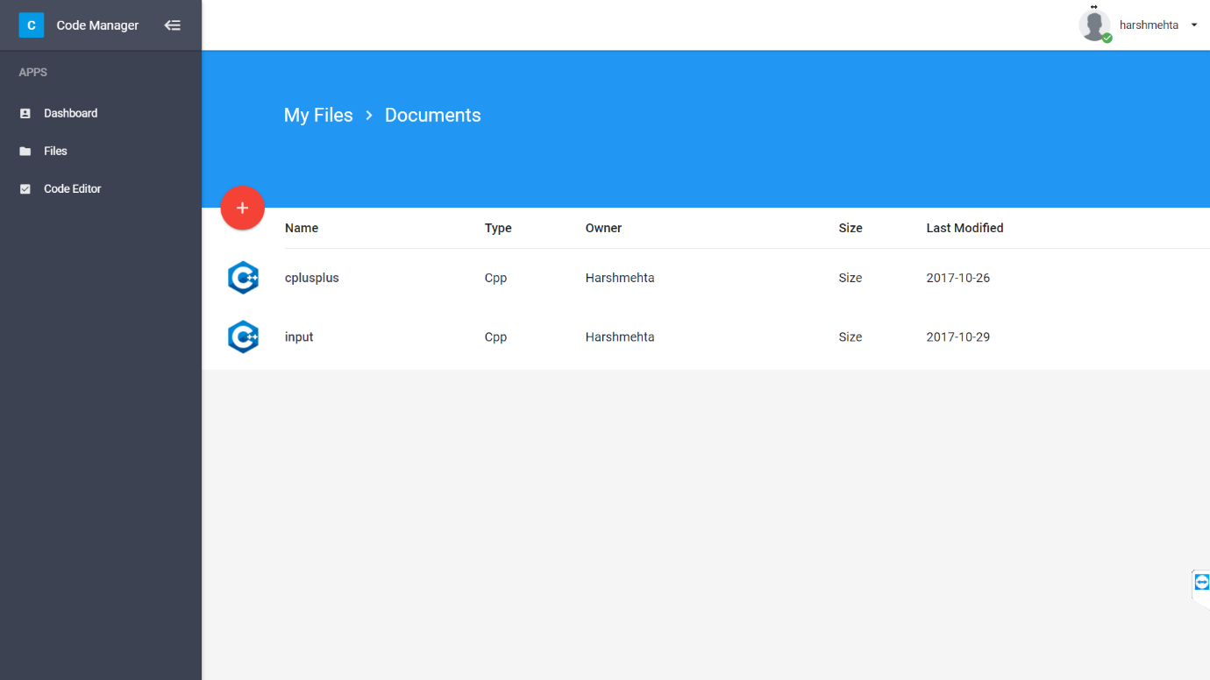  
    
    
  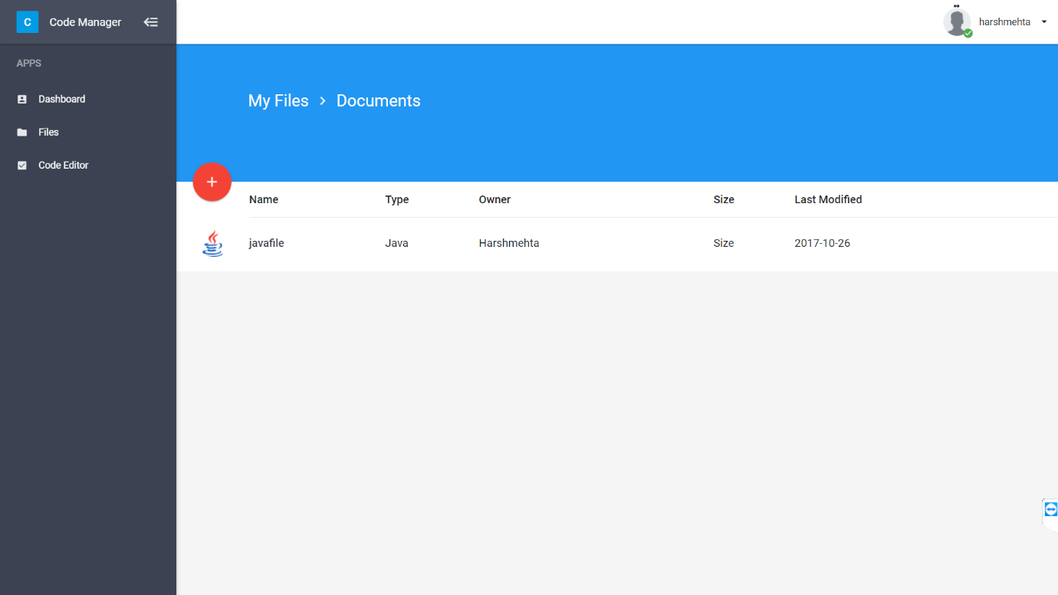  
    
    
    
    
    
    
    
    
  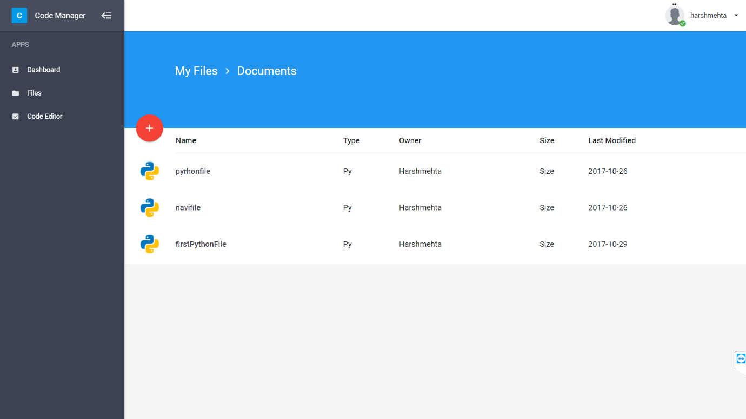

Future Work

* Code Analysis: Our IDE will show the total memory used by user’s program and total computational time of it. For finding total memory, we are going to work with proc - a file system at kernel level mode that contain the process information. Among the various information we are interested in size of data, bss, stack and virtual memory size.
* Steps to be follow
  + As soon as user submit his code, a program at server side will automatically fetch the process ID (pid) of the newly generated process
  + For almost every process running in the system, there is a directory created in /proc/. The directory name is the process id and it contains several useful files which convey important information. The two main files of our concern  are **/proc/[pid]/status** and **/proc/[pid]/statm**
  + From, these two files we get memory usage in form of files, and each page is of 1KB we multiply total pages and page size and calculate the memory usage.